DKIFER – Week 5 – Excercise 12

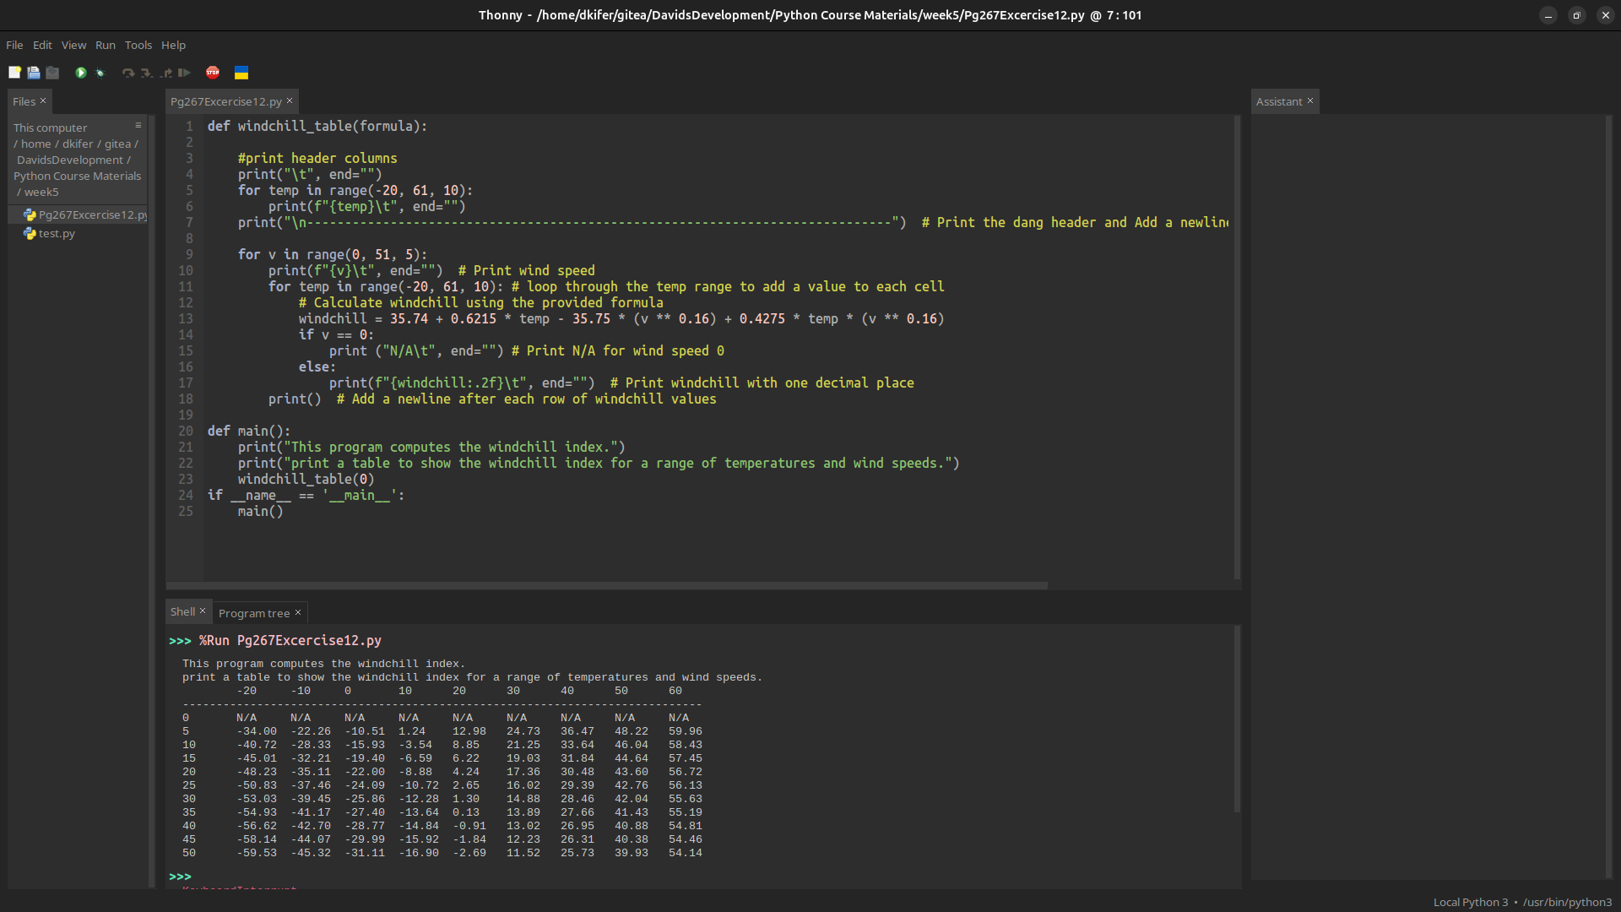
def windchill_table(formula):

#print header columns
print("\t", end="")
for temp in range(-20, 61, 10):
print(f"{temp}\t", end="")
print("\n-----------------------------------------------------------------------------") # Print the dang header and Add a newline after the temperature header

for v in range(0, 51, 5):
print(f"{v}\t", end="") # Print wind speed
for temp in range(-20, 61, 10): # loop through the temp range to add a value to each cell
# Calculate windchill using the provided formula
windchill = 35.74 + 0.6215 * temp - 35.75 * (v ** 0.16) + 0.4275 * temp * (v ** 0.16)
if v == 0:
print ("N/A\t", end="") # Print N/A for wind speed 0
else:
print(f"{windchill:.2f}\t", end="") # Print windchill with one decimal place
print() # Add a newline after each row of windchill values

def main():
print("This program computes the windchill index.")
print("print a table to show the windchill index for a range of temperatures and wind speeds.")
windchill_table(0)
if __name__ == '__main__':
main()

