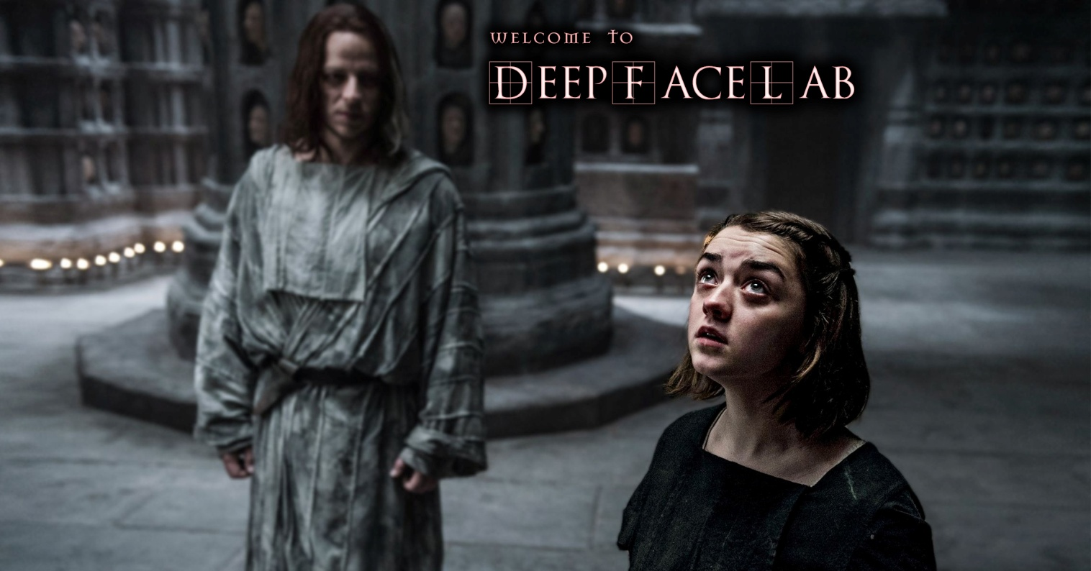
DeepFaceLab - a program to replace the person in the video using a neural network, running on NVIDIA / AMD / IntelHD Graphics graphics accelerator.
developer: iperov
website Developer: https://github.com/iperov/DeepFaceLab
capacity: 64bit
Interface language: English
Minimum system requirements:
Windows 7 and higher
processor that supports SSE instructions
2Gb RAM spooling
OpenCL-compliant graphics card (NVIDIA, AMD, Intel HD Graphics)
Recommended system requirements:
Windows 7 and higher
processor with support for AVX instructions
NVIDIA video card with 6GB video
8Gb RAM
Available assembly:
DeepFaceLabCUDA9.2SSE for NVIDIA cards until GTX1080 and any 64-bit processors.
DeepFaceLabCUDA10.1AVX for NVIDIA cards up to RTX and processors with support for AVX instructions.
DeepFaceLabOpenCLSSE for AMD cards, and any 64-bit processors.
Mirror with older versions: https://mega.nz/#F!b9MzCK4B!zEAG9txu7uaRUjXz9PtBqg

Features DeepFaceLab:
- lack ofany Presets, except on your graphics card drivers. Tested on a clean Windows 7 and 10, as well as in VMWare.

- It works on any OpenCL-compatible graphics card with 256Mb of memory and above, even quite old.

- automaticallyselects the "best" video card. So you can work with office applications on the video card is weaker, and network training will be automatically better.

- It has the opportunity to fully exercise the CPU. 8th generation of Intel processors is able to give a good demonstration of the results 2 days of training.

- all the necessary meta-data is stored directly in the individual lessons JPG files

- there is a manual selection mode officials

- have learned sorting individuals to quickly remove unwanted entities.

- Faster work with video: extraction, noise removal, assembly of the final video

Getting understand: This program does not guarantee a perfect replacement of persons in all cases! It depends on the quality of the source data, the compatibility of those light sources, etc. etc. And the technology has appeared recently (February 2018), it is far from ideal, because replaced only by a person, with no forehead and hair. You can spend a lot of time and effort, but in the end get nothing! Do you have a low chance of making a successful Faika first attempt. Only when you make a lot of attempts to create fakie with different persons, then you will understand all the nuances.

DeepFaceLab created on pure enthusiasm one person. Therefore, if you find any errors, then treat this with understanding.

See introductory video instructions on how to use to get an overview of the working process: https://www.youtube.com/watch?v=K98nTNjXkq8

refresh driver on your graphics card.
First startCUDA assembly in a clean folder of the torrent will be a long time, because compiled GPU program.

Define the terms dst and src.
src - a person who will be used for replacement.
dst - a person who will be replaced.

DeepFaceLab \ workspace- our work folder to store the entire model (video, photo, files of the program). You can rename it to keep as a backup or to work on the other.

1) clear workspace.bat
clean or create all the folders inside the workspace folder.

Put in the folder workspace your video format data_src.xxx maximum 1080 - this video taken from a person. Test video is already in the workspace folder.
You put in the folder workspace your video format data_dst.xxx maximum 1080 - this video where a person to replace. Test video is already in the workspace folder.
where xxx - any extension of the video, such as mkv, mp4, avi

2) extract images from video data_src.bat
converts video where to get the person to a set of PNG in the workspace \ data_src

Enter FPS (:? Help skip: fullfps):
how many frames of video every second extract, skip = all frames.
Output image format? (Jpg png:? Help skip: png):
The format of the output image jpg or png. Png extracts lossless, but size 10 times greater. Needless extract also slowed down significantly, especially if saved on the HDD, the SSD instead.
Here we collect pictures from which we extract the src face. The more the better.

3.1) cut video (drop video on me) .bat
optional. Crop video which replace the person for the time that you specify.
You need to drag a video file on the .bat file, the original file is saved and there is a new suffix _cut

From time (skip: 00: 00: 00.000):
the start time of pruning
To time (skip: 00: 00: 00.000):
time of the end trimming
Specify audio track id. (Skip: 0):
you can specify the audio track. It is useful, if for example you need a different language from the film.
Bitrate of output file in MB / s? (Default: 25):
bitrate Output file = 25 skip.

Test video, which already is in the folder, no need to cut.

3.2) extract images from video data_dst FULL FPS.bat
which converts video to replace the face in a set of PNG in the workspace \ data_dst
Here, the extraction only with FULL FPS, because each frame is to be processed.

3.other) denoise extracted data_dst.bat

Denoise factor? (1-20 default: 5):
the degree of noise suppression

done before removing dst parties! making the passage of the extracted video frames, removing noise while maintaining crisp edges.
Allows thereby make the final fake more plausible, because the neural network is not able to make a detailed skin texture, but the edge makes it quite clear.
Therefore, if the entire frame will be "blurred", and the fake will seem more plausible. Especially true for scenes of film, which are usually very clear.

4) data_src extract faces ... .bat
fetches a finite set of persons from PNG to workspace folder \ data_src \ aligned

Options bat files:

MT, S3FD detectors.
For optimal src MT detector.
MT - a little bit faster, it produces more false faces.
S3FD - more accurate, less false persons (recommended)
MANUAL - Extract manually is useful for src-only pereizvlecheniya already learned persons, if found somewhere errors using 4.2.other) data_src util add landmarks debug images.bat
To do this, you must manually make a backup copy data_src \ aligned \, moved from this folder to the person data_src \, do manual extraction, then combine data_src \ aligned with the backup.

GPU
Here or ALL (all) or Best (best).
If you only have one GPU, it makes no difference what to choose.
If you work in office applications on the GPU weak, and there is a strong, then you choose Best.
For maximum speed on multi-GPU choose ALL, but then the office work on the main GPU may slow down.
DEBUG
Writes workspace \ data_src \ aligned_debug each frame with dedicated individuals and facial points, thus you can watch the work of the detectors.

4.1) data_src check result.bat
view sample results people using portable XNViewMP program.
Here your goal - to remove unwanted facial.
First, you flip through scrolls and take away those unwanted persons who are in a row in large groups. No need to remove smaller groups. For this is sorted.
If the correct person is mixed with others, you start sorting the following paragraphs.
Sort of sharpness in any case do because footy src person should be removed.

4.2.1) data_src sort by blur.bat
Sort by field. You run and wait for sorting. Then look at the results. Most individuals will be cloudy at the end. For src important to clean muddy face.

4.2.2) data_src sort by similar histogram.bat
After sorting this person will be grouped by content, so that weed out unwanted person is now much easier.
You flip through scrolling and deleting unwanted persons groups.

4.2.4) data_src sort by dissimilar histogram.bat
This sorting reserves towards the end of the list of those images that have the most similar.
Usually it is the person in front, which is the most, because the actor often looking directly at the camera, or somewhere in the same direction in an interview.
Part can remove the discretion from the end of the list.

4.2.5) data_src sort by face pitch.bat
An optional item. It sorts the face so that the first face looked down the list, and the end of the list - up.
4.2.5) data_src sort by face yaw.bat
An optional item. It sorts the face so that the first list face looked to the left and to the bottom of the list - right.
4.2.6) data_src sort by final.bat
Recommended paragraph.
Target number of images? (Default: 2000):
enter the desired number of images
Automatically makes the final selection of the best individuals from any number in the target number.
Use only after a set of people cleaning other items, if you have more than 2000 persons.
Weed out persons moved to the trash (aligned_trash)
4.2.other) data_src sort by black.bat
Sorted by the number of black pixels in the bottom of the list. Face carved screen allows you to weed out.
4.2.other) data_src sort by one face in image.bat
Move to trash (aligned_trash) all images in which there was more than one person
4.2.other) data_src sort by original filename.bat
Sort according to the original file name
4.2.other) data_src util add landmarks debug images.bat
An optional item. It adds to the extracted image data_src persons with facial plotted points with a suffix to the file _debug.jpg
This allows you to manually sift very poor recovery from your set src persons.
Prior to this, do the sorting for yaw.
It makes sense to only delete those that caused his eyebrows lower than the actual, or jaw contour essentially comes to the face.
After sifting manually delete all files matching the * _debug.jpg
4.2.other) data_src util recover original filename.bat
Restores the original file name of the extracted person.

The result of the extraction src persons.
muddy persons have to be removed.
Persons closing something (hand, hair, etc.) - also need to be removed.
After bringing the set of individuals in the proper form do the final sorting sort by final.
Optionally, you can hold the item 4.2.other) data_src util add landmarks debug images.bat
You can assemble several different sets of persons of the same actor and then use them depending on the conditions dst face, placing them in a folder data_src \ aligned

5) data_dst extract faces ... .bat
The same as that of claim 4, with some differences.
Here we extract the person to be replaced.
Detector MT, S3FD?
In most cases - S3FD.
If a person is not defined in a certain frame, then this is an option + manual fix - allows you to manually specify the person for frames where there are no predefined entities.
The catch with MT + manual fix that on the frame can be defined unwanted persons other than the main, so the program does not prompt you to specify the person in this picture. In this case, you can check in a folder data_dst \ aligned_debug any person showed up at all.
In very extreme cases, or to experiment with a fully manual sampling (manual), ie for each source frame dst you manually go through and point person.
Box manual corrections officials.
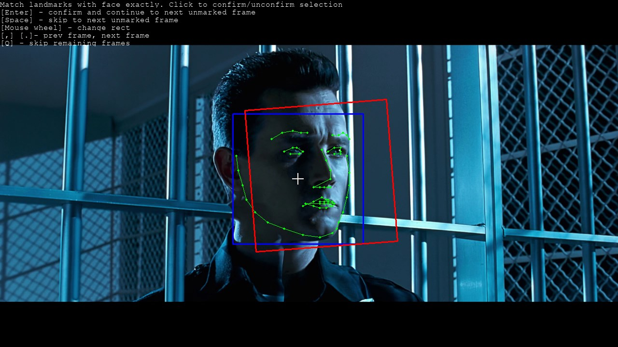
here you need to combine the green dots with a person.
Control:
Enter - confirm the person and the next frame.
Space - skip frame.
. .- move between frames
mouse wheel - change the rectangle.
Cry - fixing points
A - change the accuracy mode, affects the amount of FPS
H - hide help

5) data_dst extract faces MANUAL FIX DELETED ALIGNED DEBUG
A very important point. Directly affects the final quality of the fakes.
allows pereizvlech those frames of dst, whose results debug of clause 5.1 have been deleted by you.
What is it for? To make the fake better, you need to check dst aligned_debug frames in a folder, you can view them via the Item 5.1.
Dst improperly scribed person may lead to significant deterioration:
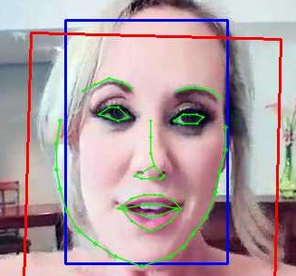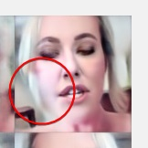
If somewhere will find that the facial contour is substantially different from the real, for example moved down to background, then you remove the footage from aligned_debug folder (item 5.1) and the run to this point.
There will be a manual pereizvlechenie remote frames. Video explaining the process:https://www.youtube.com/watch?v=7z1ykVVCHhM
5.1) data_dst check results debug.bat
see all dst frames superimposed on top of them predicted contours of the face
5.1) data_dst check results.bat
Similarly, the results look the sample face dst, and remove other non-targeted persons. A target face even turbid - reserve.
5.2) data_dst sort by similar histogram.bat
If the target video contains other unwanted persons can produce this sort, and then remove these persons will be easier.
5.3.other) data_dst sort by original filename.bat
Sort according to the original file name
5.3.other) data_dst util recover original filename.bat
Restores the original file name of the extracted person.

The result of the extraction of dst persons.
Your goal is to remove only the target person (even hazy) of each frame by removing all other persons.

5.4) data_dst mask editor.bat Manual correction masks dst persons.

An optional item.

Applicable only for SAE MODELS with the option of studying a mask or by examining the options of style.
Attention: You can spend a lot of time, but did not get improved results.

You can manually adjust the mask dst persons to remove such obstacles from his face.
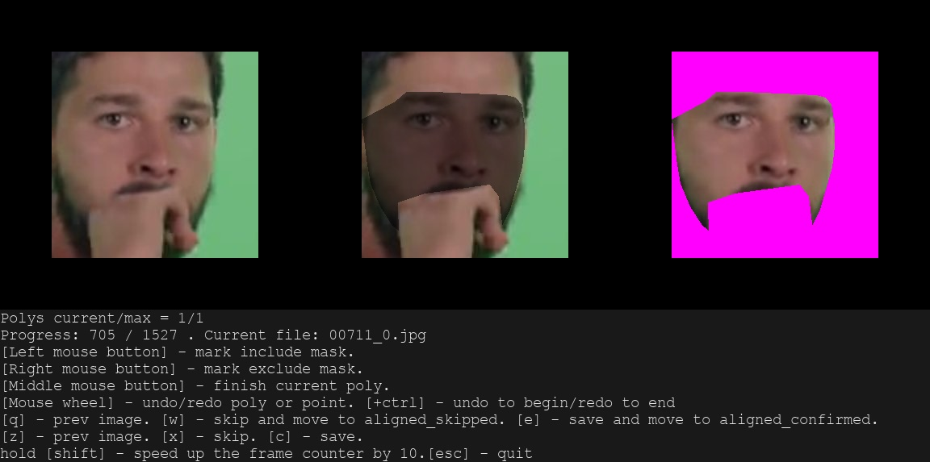
Result of conversion:
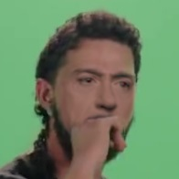
Sophisticated mask harder to train.

Management in the Mask Editor.

Left mouse button - including the mask mark. Right mouse button - eliminating the mask mark.
Middle mouse button - to complete the current polygon.
Mouse wheel - undo or redo actions with points. Hold ctrl - will move to the beginning or end of the story.
The W - skip it and move to folder aligned_skipped - applicable for sorting people into a different folder. In most cases, you do not need this action.
E - save and move aligned_confirmed folder. - applicable for sorting people into a different folder. In most cases, you do not need this action.
C - flow into the same folder.
X - to save in the same folder.
Q / Z - previous image.
Sandwiched SHIFT - accelerates the movement of the HR 10.
ESC - exit.

6) train ... .bat Training.
disable any program that can use video memory.
If in the process of launching the training got a lot of text that contains one of these words:
Memory Error
Allocation
OOM
then on your GPU model does not start, and you need to trim a model for this, see the description of the options models.
When you first run the model, the program will ask about the different options that are saved and will be used for subsequent runs.
Simply pressing Enter - will use the default values.

Which GPU idx to choose? (Skip: system choice):
With multi-GPU can train one scene to the different models and options of the same model without cloning folders. Just choose GPU code at the start of exercise / conversion, and then the model files in the workspace folder \ model will be prefixed with this GPU in the name.
If you leave the GPU choice by default, then choose the best GPU and model files will not be prefixed.
Write preview history? (Y / n skip: n):
Do write history preview of the disc
Target iteration (skip: unlimited):
Target iteration, to achieve that training will stop.
Batch_size (skip: model choice):
range of batch sizes - this is how many images at a time is fed to the neural network training. By default, selected low value, but you can pick up this value to below your video card. The bigger, the better.
Feed faces to network sorted by yaw? (Y / n skip: n):
feeding patterns src persons sorted according to the same direction as dst. The idea is to feed just the right person. However, it is not fully tested is good or bad.
Flip faces randomly? (Y / n:? Help skip: y):
feeding model, all face accidentally inverted horizontally. When the final face off options will be more natural, but then src assembly of persons shall cover all angles of rotation.
Src face scale modifier% (-30 ... 30,:? Help skip: 0):
scaling modifier src persons. If src face wider than dst and fake to get bad, it makes sense to slightly reduce this value.

If the model is run for the second time:
Press enter in 2 seconds to override some model settings.
If you press Enter for 2 seconds, then it will be possible to replace some of the model options.

List of training models. Also it specifies the minimum requirements for GPU memory.
H64 (2GB +) | half of the face with a resolution of 64 - this is the original FakeApp or FaceSwap, only better at the expense of training the neural network + mask excludes the background around the face + amended converter. For graphics cards with video memory 2 and 3GB of this model works in a reduced mode, ie, quality will be less than 4GB.  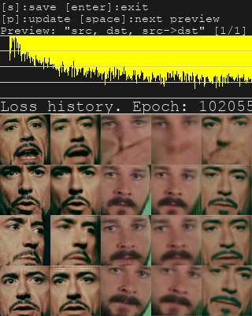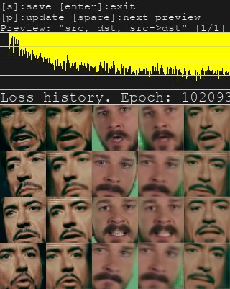
H128 (3GB +) | as the H64 is only with a resolution of 128. However, half of the face may be poorly trained in some light conditions and head rotation, etc. For graphics cards with video memory 3 and 4Gb this model operates in reduced mode, ie, quality will be less than 5Gb.  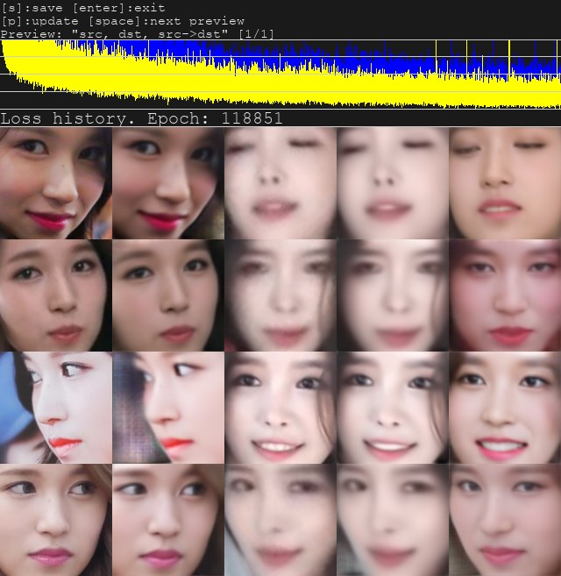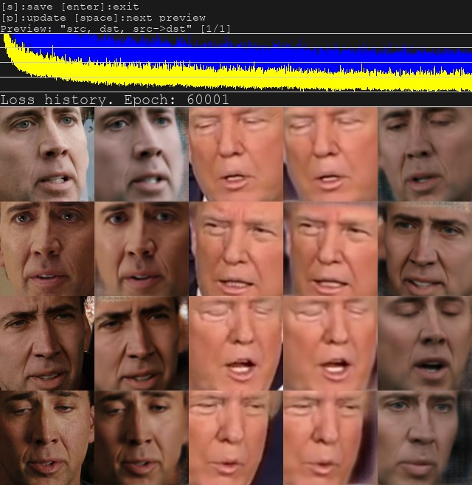

options for H64 and H128:
Use lightweight autoencoder? (Y / n,:? Help skip: n):
choose a stripped-down model. It is necessary for video cards with <= 4Gb video memory.

DF (5GB +) | model from dfaker. Full-face model with a resolution of 128, a smart training feature persons excludes the background around the face.  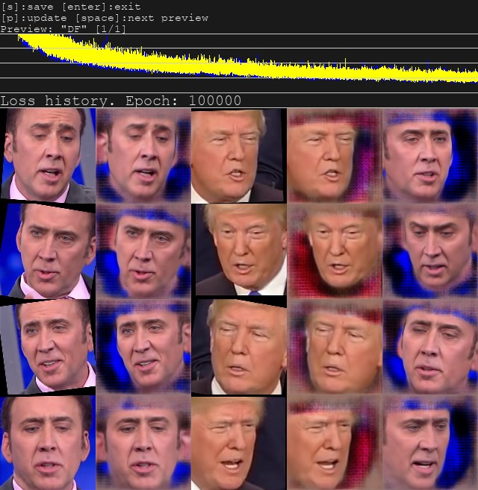
LIAEF128 (5GB +) | like the DF, only trying to morph the original face of the target person, retaining the original features of the face. Morph is not always good, and can do no recognizable face, then choose DF.  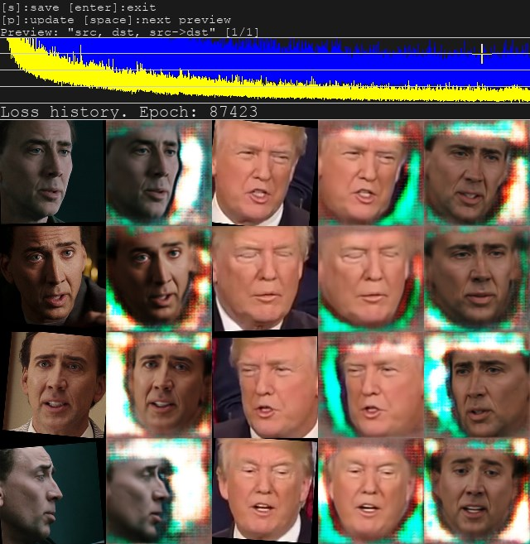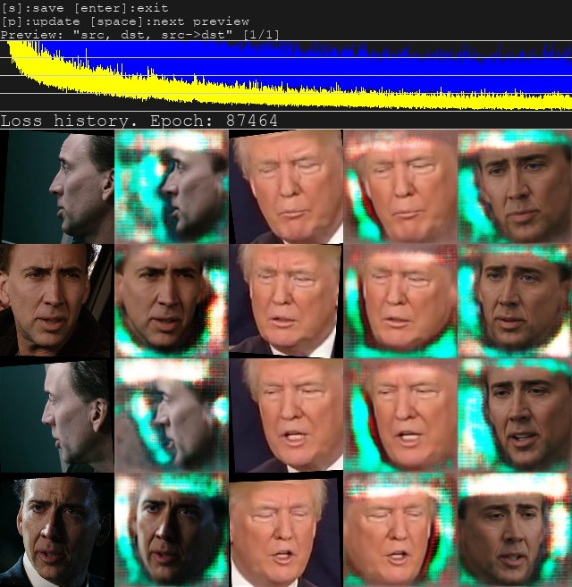

options H64, H128, DF, LIAEF128 models:
Use pixel loss? (Y / n,:? Help skip: n / default):
It makes it easier to improve the fine details and remove jitter. Include only after 20k iterations.

SAE (512MB +) | The latest best and flexible model. It contains all of the other models. It is possible to transfer the style of face and lighting, which will be studied directly by the neural network. Various settings can be configured when you first start. These settings affect what size will the network and I run on your video card, so you can adjust the model to the training as well as 512MB to 24GB. Of course, the more memory, the better quality you get.  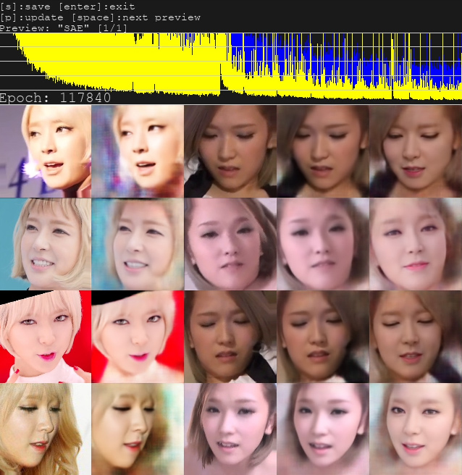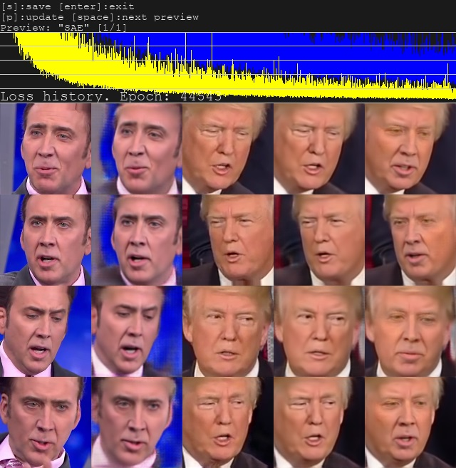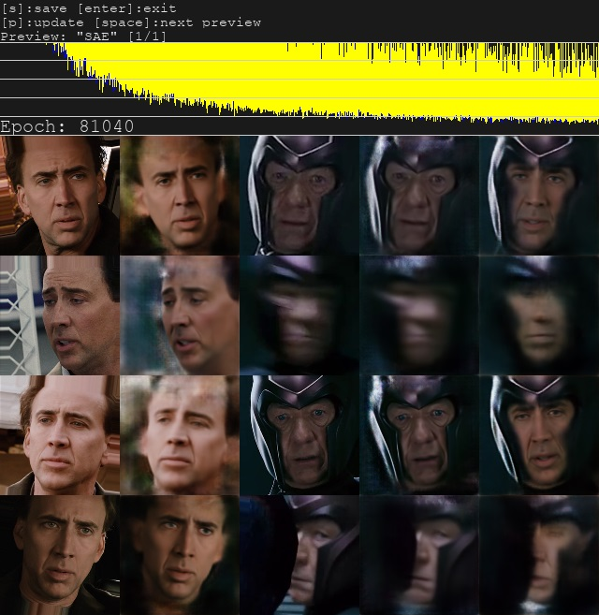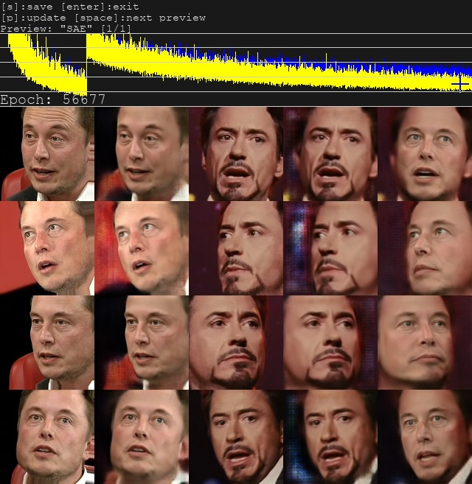  EXAMPLE Faika Cage-Trump: https://www.youtube.com/watch?v=2R_aqHBClUQ  Example Faika Elon Musk - Robert Downey jr: https://www.youtube.com/watch?v=OLWFnPwzgEY
options only for SAE model:
Resolution (64-256:? Help skip: 128):
resolutionperson. More resolution - requires more memory, longer trains model. You can select any value from 64 to 256 fold 16.
Half or Full face? (H / f,:? Help skip: f):
Half or full size of the face
Learn mask? (Y / n,:? Help skip: y):
learn whether the mask. From the study, the mask will be smoother and less trembling, otherwise it will use the rough. However, in a stylized exercise you can do without the study of the mask.
Optimizer mode? (1,2,3:? Help skip:% d):
This option is only NVIDIA video cards. optimizer mode neural network. 1 - by default. 2 - allows you to train the network x2 larger, require more RAM. 3 - allows you to train the network x3 larger, require more RAM and up to 30% slower.
AE architecture (df, liae, vg:? Help skip: df):
type of architecture of the neural network.
AutoEncoder dims (128-1024:? Help skip:% d):
the number of network dimensions. All information about individuals will be packed into these dimensions. If these are not enough, for example, closed his eyes will not be recognized. More - better, but can not start because of insufficient memory. Can be reduced to achieve the performance on your video card.
Encoder dims per channel (21-85:? Help skip:% d)
the number of dimensions of the rotary encoder network model helps to identify patterns of large faces, more - better, but can not start because of insufficient memory. Can be reduced to achieve the performance on your video card.
Decoder dims per channel (11-85:? Help skip:% d)
the number of dimensions of the network decoder, helps increase the detail, more - better, but can not start because of insufficient memory. Can be reduced to achieve the performance on your video card.
Add residual blocks to decoder? (Y / n,:? Help skip: n):
Add additional blocks to the decoder to increase detail. It consumes more CPU resources.
Remove gray border? (Y / n,:? Help skip: n):
Remove the gray line on the border of the predicted face. It requires more computational resources.
Use lightweight encoder? (Y / n,:? Help skip: n):
whether to use a lightweight encoder, it is faster by 35%, but not tested at various stages.
Use multiscale decoder? (Y / n,:? Help skip: n):
whether to use multiscale decoder allows to achieve higher definition.
Use pixel loss? (Y / n,:? Help skip: n / default)
It makes it easier to improve the fine details and remove jitter. Include only after 20k iterations.
Face style power (0.0 .. 100.0:? Help skip:% 1f.):
speed transfer of studying a person of style, such as lighting and color. May cause artifacts at large. Floating-point number. 0 - do not teach
Background style power (0.0 .. 100.0:? Help skip:% 1f.):
speed studying the background around the face. In most cases, morphic face in dst. Floating-point number. 0 - do not teach
During training, you can go through the Enter, pressing it into the window Training preview, and run at any time, the model will continue to be counted from the same point.
Train of 24 hours or more. When the result is satisfying - and leave through the Enter, pressing it into the Training preview window.
'P' button (on the English keyboard layout) in Training preview window updates the preview.
In the Training preview as we can see the curve of error. Falling, it shows the progress of training over time.

The result of the training.
You choose the model according to the scene and your personal experience.

7) convert ... .bat Overlay persons.

You choose the model and the GPU number (if you have more than one) with which to train.
debug option allows you to see the process of applying persons and some technical information for each frame in the console, press the space bar in the preview window.
The basic concept of blending faces.
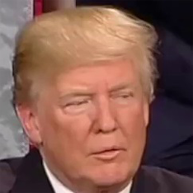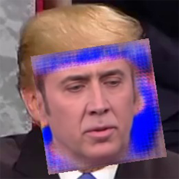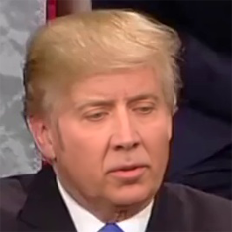
Next, when you run the program asks about the options:
Choose mode: (1) overlay, (2) hist match, (3) hist match bw, (4) seamless (default), (5) raw:
Selecting the overlay persons.
modes
Overlay | direct overlay of the predicted face of neural network without pre-treatment
Hist-match | overlap with the histogram equalization. |  |  | 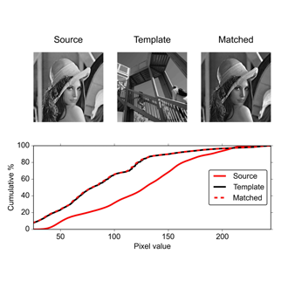
Histh-match-bw | overlap with the histogram equalization channel of grayscale.
Seamless | the imposition by the Poisson  "Poisson image editing." ACM Transactions on Graphics (TOG). Vol. 22. No. 3. ACM, 2003. |  |  | 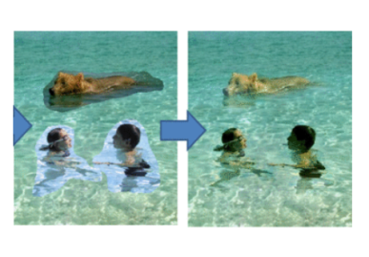
Raw | get the green layers for its own processing in the video editor, such as After Effects. |  |  | 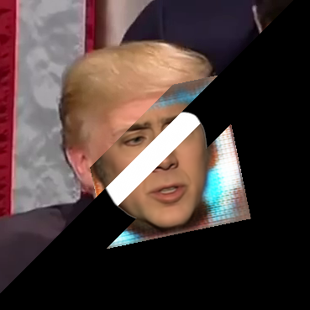
By default, if you press Enter - choose seamless.
Which to choose? It depends on the case. You try everything and see the result.
options
Suppress seamless jitter? [Y / n] (:? Help skip: n):

For the regime seamless. Suppresses jitter person arises only in seamless mode. Enabling this option will make the conversion process is several times longer.
Seamless hist match? (Y / n skip: n):

For the regime seamless. Include whether the histogram equalization.
Masked hist match? (Y / n skip: y):

For modes hist match, hist match bw, seamless, indicates whether the histogram equalize the mask face.
Mask mode: (1) learned, (2) dst, (3) FAN-prd, (4) FAN-dst (5) FAN-prd * dst (6) learned * FAN-prd * FAN-dst help (?) . Default - 1:

Mask type.
Learned - Learnedmask if you have selected the option Learn mask. The contours of the mask mitigated, but can sometimes shake.

dst - crude mask obtained directly from individuals dst, so quivering contours of the mask.

FAN-prd - Mask received predtrenirovannoy FAN model of the predicted face. Facial contours are not trembling.

FAN-dst - Mask received predtrenirovannoy FAN model of dst face. Facial contours are not trembling.

FAN-prd *dst - the mask obtained by multiplying the FAN-prd and FAN-dst

learned * FAN-prd * FAN-dst - a mask obtained by multiplying the learned, FAN-prd and FAN-dst

The advantage of FAN masks: you can not get a trembling mask, without studying its model.
Lack FAN masks: may issue artifacts on the contours of persons.
Learned |  | dst | FAN-prd |  | FAN-dst
 |  | 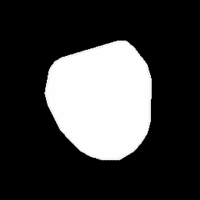 | 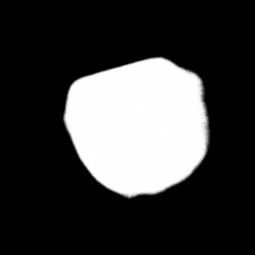 |  | 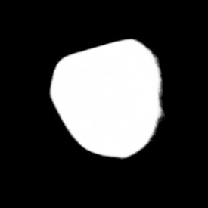
Choose erode mask modifier [-200..200] (default 0):

Specify how to reduce the size of dst mask. The value of <0 - expand mask. This adaptive value, not absolute.
-100 |  |  | +100
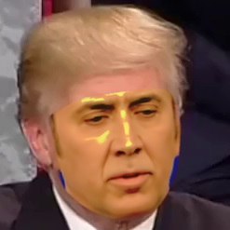 |  |  | 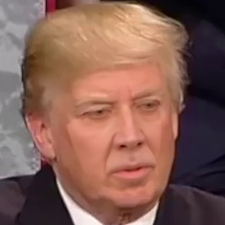

erode mask modifier also reduces flicker in seamless mode,
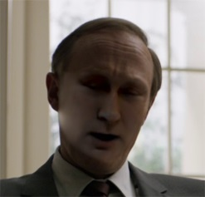 | 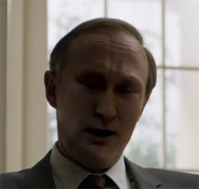
Choose blur mask modifier [-200..200] (default 0):

You specify how smooth dst mask. The value of <0 - reduces aliasing default models H64 and H128. This adaptive value, not absolute.
-200 | +200
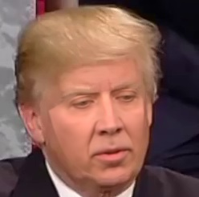 | 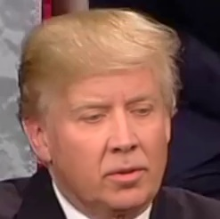
Hist match threshold. [0..255] (default - 255):

Reducing the value suppresses artifacts for histogram equalization modes.
(Default) 255 | 231
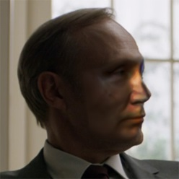 | 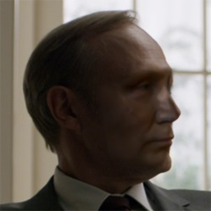
Choose output face scale modifier [-50..50] (default 0):

change the scale of the output face in the range -50 to + 50%. It is useful when the person predicted slightly more original.
-50 | 50
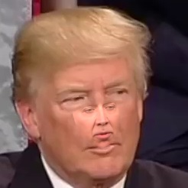 | 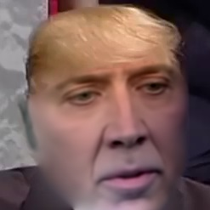
Apply color transfer to predicted face? Choose mode (rct / lct skip: None):

further adapt the complexion using rct or lct algorithm
Dst face | predicted face
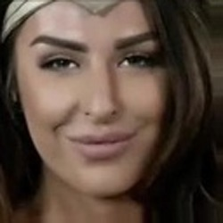 | 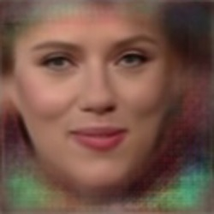
rct | lct
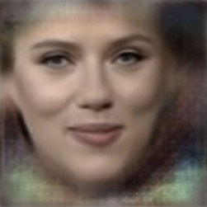 | 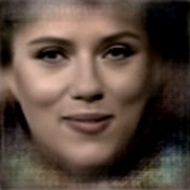
Apply super resolution? (Y / n skip: n):

Apply whether "increasing the resolution" technique to enhance image detail. Slightly improves the clarity of edges, such as around the eyes.
No | Yes
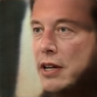 | 
Degrade color power of final image [0..100] (default 0):

The degree of degradation of the final color image from 0 to 100. By reducing the overall quality of pictures can be hidden overlay facial imperfections.
0 | 100
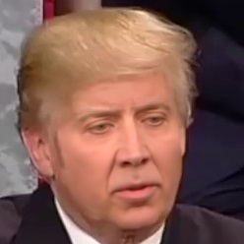 | 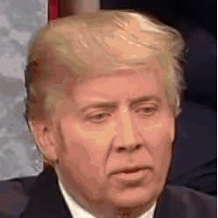

Export png with alpha channel? [0..1] (default 0):

exports only person with an alpha channel for further work in the video editor.
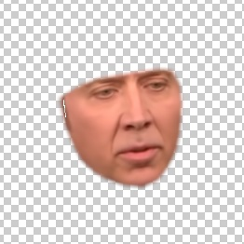

The result of the imposition of individuals.
At the beginning of start debugging, trying different settings and watch the result.
Remembering the appropriate values, run without the imposition of debugging.

Result images in workspace \ data_dst \ merged - can be used in most video editor, or glued to video in claim 8

8) converted ... bat Glued to the video.

The following .bat files glue the picture in the video with the same sound and FPS that data_dst.mp4 - so do not delete data_dst.mp4 of workspace folders.

to avi.bat
to avi
to mp4.bat
in mp4 format
to mp4 (lossless + alpha) .bat
mp4 lossless using alpha channel.
to mov (lossless + alpha) .bat
mov lossless using alpha channel. Sony Vegas using QuickTime can use the alpha channel from the mov file.

Everything. The result in the workspace \ result.mp4
If the result is not satisfied, you can try different blending options, or to continue to train to improve the clarity, or to try a different model, or try a different starting person.

Additional Information:

9) util convert aligned PNG to JPG (drop folder on me) .bat
It allows you to convert a folder with the extracted PNG faces of the older versions DeepFaceLab to JPG. To do this, drag the folder to a set of individuals directly on the .bat file.

There are cases when Windows 10 reserves% of video memory, even if the card is not used to display an image. In such a case you have to sacrifice something to training run (batch size, dimension in SAE, etc.).

Tips and Tricks.
Narrow face better trained on the broad face. That's why fakes with Cage are so popular.

SometimesIf the neural network will receive dst face only one light, for example, Shadowed nose, with src persons do not contain the same person with the same lighting, the neural network can not understand where all looking face at some angles, resulting in a predicted face It will contain a wrong turn heads. | 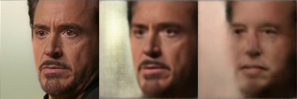
In this case it is useful to add to the training set data_dst \ aligned faces of the same character, but learned from other scenes with different lighting. | 
It is thus possible to improve somewhat the result. But best of all, of course, find src face with the same coverage of the nose. | 

Advanced tips from @ GAN-er (in English only):
Tip 1:
You may benefit by starting with a small batch size (within reason) and increasing it later. The reason is that a ** large batch size will give you a more accurate descent direction but it will also be costlier to calculate **, and when you just start, you care mostly about the general direction; no need to sacrifice speed for precision at that point. There are plenty of sources discussing the batch size, as an example you can check this one:
https://stats.stackexchange.com/questions/164876/tradeoff-batch-size-vs-number-of-iterations-to-train-a-neural-network
Tip 2:
Unlike the batch size that the only thing that does is affecting how accurate each step will be as far a the true gradient goes, the dimensions, actually, increase the complexity of your NN. As a rule, ** the more complex a network the better the resulting model **, but since nothing comes for free, ** the more complex the network the more time it will take to converge **.
What you generally want is to ** _ figure out the max dimensions that you can use _ ** given your GPU's memory, and your desired max batch size.
You can set the max batch size to something, say K, and then increase the dimensions until you get OOM errors. In the end, you will end up with a triplet, {batch size, ae_dims, ed_dims}
Ideally, you would use 1024 and 85 for your autoencoder and encoder / decoder dimensions, but no card has enough memory for such a configuration even with batch size 1.
Remember that unlike batch size that you can change at will, once you set up the dimensions you can not change them.
Note that ** if you use a complex - high number of dimensions NN, in combination with a small batch size, it will take _considerably_ longer for your model to converge **. So keep that in mind! You will simply have to wait longer, but also you will get a much much better result.
For cards with 11Gb of memory, and for SAE you can try the following settings:
For DF architecture: 12698 51 For LIAEF architecture: 8402 47
Tip 3:
If you end up being stuck, ie the loss does not go down but for no obvious reason or if you get weird artifacts in some previews before you discard and start from scratch, you may want to flip your DST and SRC for a while. This often is all you need to keep things going again.
Tip 4:
99.995% of your success or failure rate is due to bad SRC or DST sets. This means that 99.995% of your time should be spent in actually ensuring that your sets are well curated. Throwing together a hot podge of material and expecting a decent outcome is guaranteed to result in disappointment. Garbage in, garbage out.

Additional description of SAE.

This model is in fact contains all the other models, if you disable style training and multiscale decoder.
SAE very flexible, can be adjusted either by a better generalization of network entities, or under better image clarity, or just to cash in on your GPU.
If src assembly of persons contains the number of persons greater than dst, the model can not converge. In this case, use the option Feed faces to network sorted by yaw.
If src face wider than dst, the model can not converge. In this case, you can try Src face scale modifier option -5.
df architecture makes the face more like the src, but if the model does not fit, use liae.
VG SAE architecture has not yet shown any improvement, you need more tests.
If your video card is a lot of video, you can choose between a large batch size, which improves the generalization of persons and Encoder / Decoder dims dimensions that improve picture quality.
Face styletrains to move complexion, lighting, make-up. If he has already moved well, it continued training with a high score can make artifacts.
Background styletrains, to transfer the facial contour and the environment. Due to the contour of the face, adapted src face under dst circuit.
How best to train SAE with style? There is no better solution, it all depends on the stage. Experiment with style settings to your liking. Enable write preview history and track changes. Make a backup file every model 10k iterations. You can roll back the model files and to change the values, if something went wrong in the preview stories.

The work built on AMD / Old NVIDIA / IntelHD cards.
DeepFaceLab It supports older processors without AVX instructions. To do this, use DeepFaceLabCUDA9.2SSE assembly.
DeepFaceLab It supports AMD, IntelHD Graphics and any old GeForce graphics cards through the use of OpenCL 1.2 engine.
To do this, use DeepFaceLabOpenCLSSE assembly.
Work on OpenCL compared to CUDA has some drawbacks:
- extraction of persons can only be run or MT S3FD, with the first pass (1st pass) on the MT will still work on the CPU, but fast enough! S3FD runs completely on OpenCL and is the preferred method. The second pass is working on OpenCL without problems.
- To start the SAE, it needs to be cut back significantly in ae_dims, ed_ch_dims and the batch size in comparison with the same amount of video memory on the CUDA version.
You can put even the most minimal value, as well as the resolution of 64 and half face - as a demonstration natreniruete fake inferior quality even IntelHD Graphics with 256MB of memory with no problems!
- each training run and after saving in the process of training, OpenCL will restart your routines that will take some time.

Donation development.
If you like this program, you can donate money for further development.

 |  | 
Yandex.money | https://money.yandex.ru/to/41001142318065
Paypal | https://www.paypal.com/cgi-bin/webscr?cmd=_s-xclick&hosted_button_id=KK5ZCH4JXWMQS&source=url
bitcoin: 31mPd6DxPCzbpCMZk4k1koWAbErSyqkAXr

useful links

development page | https://github.com/iperov/DeepFaceLab
Introductory video instruction on how to use | https://www.youtube.com/watch?v=K98nTNjXkq8
My channel fakie | https://www.youtube.com/channel/UCEtoVzBLuE-ni-54h7kYvsg
Popular channel fakie | https://www.youtube.com/channel/UCUix6Sk2MZkVOr5PWQrtH1g/videos
Fakes on REDD | https://www.reddit.com/r/GifFakes
Ready src kits for individuals DeepFaceLab | https://mega.nz/#F!y1ERHDaL!PPwg01PQZk0FhWLVo5_MaQ
search for a suitable celebrity face on the downloaded | http://www.pictriev.com
to find a suitable person on the downloaded porn star | https://findface.sex/ru  https://findpornface.com  https://pornstarbyface.com  http://www.didshedoporn.com

